Strategic Human Resource Planning In Academia
Purpose of human resource management is to:
- ensure the organization has adequate human resources to meet it goals and operational plans,
- allow the organization to stay apprised of the current social, economic, legislative, and technological trends that affect human resources, and
- allow the organization to remain flexible to the dynamic changes in the environment.
The basic questions to be answered for strategic human resource management are:
- Where are we going?
- Given the circumstances, how will get there?
Vetter (1967) defined human resource planning as “the process through which management determines how the organization should move from a current manpower arrangement to a more desired arrangement.” By the use of strategic planning, management aims to have the right number and the right kind of employees, at the right place at the right time, performing actions which result in long-term benefits to both the individual and the organization.
The Process
- Assesing the current human resource capacity.
The knowledge, skills, and abilities of current employees need to be identified. The skills inventory should go beyond the skills needed for the particular position. Special skills that relevant to the position are needed. The result of this assesment can be reviewed to determine if the person is ready and willing to take on more responsibility and to look at the person’s current development plans.
- Forecasting human resource requirements.
The second step is to forecast human resource needs for the future based on the strategic goals of the organization. This assesment must focus on how the external environment may impact human resource needs. Modeling and forecasting can give management important information about the implications of different human resource strategies that can be used to support the goals of the organization.
Three types of modeling techniques are demand forecasting (regression analysis, time series analysis, and simple percentage changes), integrated man power planning (linear programming, goal programming, and network models), and supply forecasting (replacement charts and more popular methods based on a Markov model).
- Gap analysis.
This step is to determine the gap between where the college wants to be in the future and where it is now, includes identifying the number of faculty/staff and the skills and abilities required in the future.
- Developing human resource strategies to support college strategies.
  - Restructuring strategies
    - Reducing staff either by termination or attrition
    - Regrouping tsks to create well designed jobs
    - Reorganizing work units to be more efficient

The key to success is to ensure that the employees are satisfied with the arrangement and that it meets the needs of the organization.
  - Training and development strategies
    - Providing faculty/staff with training to take on new roles.
    - Providing currenct faculty and staff with development opportunities to prepare them for future jobs.
Human capital theory separates training into two types: general training (provided by an organization that another organization can use) and specifi training (have a little use in the other organization).
  - Recruitment strategies
    - Recruiting new faculty/staff with the skills and abilities that our college will need in the future.
For strategic human resource planning, each time the college recruits it should be looking at the requirements from a strategic perspective keeping in mind that recruitment involves the creation of a pool of qualified applicants from a variety sources.
  - Outsourcing strategies
This is particulary helpful for accomplishing specific, specialized tasks that don’t require ongoing full-time work.
    - Using external individuals or organizations to do some tasks, many organizations look outside their own human resource pool and contract for certain skills.
  - Collabortation strategies
    - Working with other organizations in the development of promising individuals.
    - Sharing the costs of training/development.
    - Allowing faculty/staff to visit other organizations to gain skills and insight.
Documentation
This is a brief document which states the key assumptions and the resulting strategies along with who has responsibility for the strategies and the timelines for implementation.
Implementation
- Agreement with the plan
It is important that there be agreement and ownership with the strategic human resources plan being implemented.
- Communication
The strategic human resource plan needs to be communicated throughout the organization.
- Compliance
The strategic plan should be complies with existing laws, regulations, and contractual obligations.
- Needs
The strategic should consider the implications for space, equipment, and othe existing resources that he human resource plan will have uplon the organization.
- Evaluation
Human resource plans need to be updated on a regular basis and need to establish the information nescessary to evaluate the success of the new plan.

Source: Ulferts, G., Wirtz, P., & Peterson, E. (2009). Strategic human resource planning in academia. American Journal of Business Education, 2(7), 1.

An Empirical Study On Fit Between Strategic Human Resource Management and Business Strategy
There are two views about the relationship between Strategic Human Resources and business strategy: the contingency scholars think, human resources strategy is determined by the organizational strategy, organizational strategy and human resource strategy is a one-way relation; and Resource-based view that organizational strategy and human resources strategy is a two-way influence relationship.
Truss and Gratton (1994) defined SHRM as the combination of the human resources function, strategic, goals and objectives of the organization.
An Overview of Business Strategy
There are many definitions about strategy. Chandler described the strategy as “a corporate decision-making about long-term goals, as well as the action taken by the organization to achieve these goals”. To the organization, there are different levels of strategy.
- Strategic Level
Strategy divided in to three levels: Corporate Strategy, Business Strategy, and Functional Strategy.
- An Overview of Business Strategy
Business strategy also known as competitive strategies. Venkatratman (1985) concluded that the business strategy is a general model, which is composed of various means used by an enterprise to achieve business goals. Three basic competitive strategies: Overalla Cost Leadership Strategy, Differentiation Strategy, and Focus Strategy.
An Oveview of SHRM and Its Relationship with The Business Strategy
- An Overview of Strategic Human Resources
McMahan (1992) defined SHRM as the patern of planned human resource deployments and activities intended to help an organization to achieve its goals.
- The Relationship between SHRM and Business Strategy
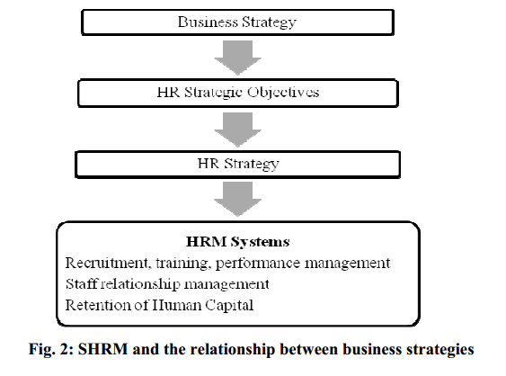
The contingency scholats think, human resource strategy is determined by the organizational strategy, organizational strategy and human resource strategy is a one way relationl and resource-based view that organizational strategy and human resources strategy is a two-way influence relationship. The contingency scholars believe that SHR derives from business strategy, business strategy determine how much companies need ti put forward the number of employees, skils, abilities, etc., so requiring human resources strategy must support the business strategic. Human resource strategic will be laid down, and then determine the human resources strategy. Through human resource management system, strategies are implemented to help an organization to achieve its goals.

Study On The Path SHRM Supports Business Strategy
This paper argues, SHRM’s support of business strategy has three paths, namely, by looking for the best human resources practices and pay efforts to implement; analyze business strategy and found out the Human Resource Policy Clusters, maintain the internal matching, and mathicng with the external business strategy.
- The Path of Best Practice Perspective
There is considerable academic debate about human resource management to help companies build competitive advantage. Seven human resource practices by Pfeffer are employment security, recruitment and selection, self-management teams and decentralization of decision-making, high performance based performance, training, narrowing the gap between management level, and information sharing.
- The Path of The Contingent Perspecive
The process of making human resource management needs to consider many contingent factors, including strategic, company size, ownership type, and so on. Different strategies require different human resource management model. The path from the contingent perspective can be followed by analyzing which cycle the companies are, and slect the most appropriate human resource practices to fit the organization, to achieve optimal performance.
- The Path of Configuration Perspective
Human Resource policy clusters are designed to support human resource strategies in a way tat is congruent with the overarhing business strategy, they have Vertical Fit. When they are aligned with each other to create powerful connections, there is Horizontal Fit. Fit perscpective is concerned about how the number of independent variablesassociated with the dependent variables.
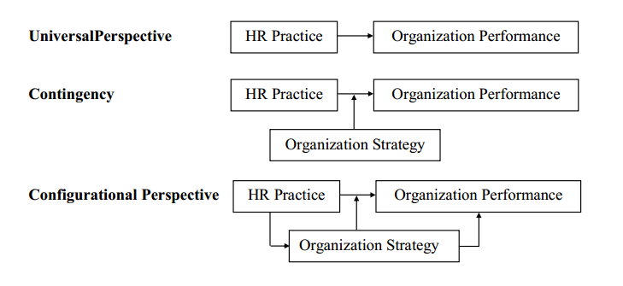

Source: Gupta, M. (2016). AN EMPIRICAL STUDY ON FIT BETWEEN STRATEGIC HUMAN RESOURCE MANAGEMENT AND BUSINESS STRATEGY.International Journal of Management Research and Reviews, 6(2), 102.

