Employee Job Search Motivation factors:
An evidence from electricity provider company in Malaysia
- Background
Recruitment has a crucial impact on decision-making within the organizations and by individuals (Momin, & Mishra, 2015; Breaugh, 2012). Job dissatisfaction is an important issue for many people including managers, customers and employees, as well as a matter for organizations. This is because, in general, job dissatisfaction probably contributes to several issues such as mental and physical health, lower level of turnover and absenteeism (Jha & Bhattarcharrya, 2012). Voluntarily turnover has been detected as the serious problem for some companies in Asia such as Malaysia, Taiwan, etc (Ahmad & Bakar, 2003). Ramlal (2004) views that job hopping has become a culture for many employees in Asia. These show the employees that are having unpleasant feelings about job may lead individuals to search alternative mechanisms in order to reduce the dissatisfaction (Jha & Bhattacharrya, 2012).
- Understanding job search motivation in recruitment context
Motivated employees are needed to ensure the operational health of each organisation. This is because motivated employees help businesses to succeed, as they are more productive (Almacik et al., 2012). Hence, motivated employees can contribute to making an organisation more valuable and profitable (McKenzie-Mohr & Schultz, 2014). From a job search view, motivation is an encouragement for employees to search for a new job (Altmam et al, 2015). This is because the employees expect that their expectation can be fulfilled in the new place perhaps. The expectations can be viewed in terms of 1) a new expectations (after they started or they have experienced for sometimes in their existing job) or 2) the expectations that they expected since day one they started their existing job.
In relation with the above discussion, job search motivation does reflect the preference of job characteristics within job search context; the right job characteristics able to attract a range of quality job applicants ( Costello, 2006). In contrast, failure to attract the right job applicants indicates the unsuccessful results of recruitment (Swider et al, 2015). Recruitment from the employee’s perspective is about an employee’s attempts to match his/her knowledge, skills and ability with the opportunities offered by the employer (organisation) (Kristof, 1996); it is more about an employee’s desire to satisfy their desires and needs.
  - Job search motivation factors
Helepota (2005) defines motivation as “a person’s active participation and commitment to achieve the prescribed results”. For example, when an employee’s income increases, money becomes less of a motivator (Kovach, 1987). Therefore, it is crucial to understand the factors (intrinsic and extrinsic) that may cause the changes in employee motivation.
Many previous researchers (Almacik et al., 2012; Hayati & Caniago, 2012; Helepota, 2005; Deci & Ryan, 1985; Gallagher & Einhorn, 1976; Herzberg, 1966) noted that intrinsic motivation factors contribute to the improvement of job tasks completed by the employees. In addition, Herzberg (1956) argues motivation is derived from the intrinsic motivation factor. In addition, intrinsic motivation also contributes to the individual having fun and enjoying creativity in doing the work/job (Schmidhuber, 2010). The relationship between job performance and job satisfaction has been supported by the work of Hancer and George (2003), Iaffaldano and Muchinsky (1985), and Springer (2011). Job performance and job satisfaction generate positive attitudes (Linz & Semykina, 2012), the end result of which is the success of recruitment because of the best fit between the employee and the organization (Breaugh, 2012).
The discussion above leads to the identification of factors generating extrinsic motivation as those that surround the job. These include wage, peer relationships, supervision, workplace conditions and company policy. In addition, there appears to be a relationship between extrinsic and intrinsic motivation.
In most of the prior research, different job types or job levels were used as construct components for measuring intrinsic or extrinsic motivation.
- The measurement of job search motivation
The literature mentions a variety of ways for using motivational factors in job search research. From the discussion above it can be seen that job search motivation factors are factors that are of concern to the internal and external conditions of the job itself. Thus, this research divides job search motivation factors into three sections: (1) salary; (2) the environment; and (3) job characteristics.
- Data collection
A sampling frame for this research is taken from a list of employees of an electricity provider company in Malaysia. The organization has ranges of job categories, level and job supervision responsibility. The employees were randomly selected and restricted to only who has or less than three years working experience in the organization. This is to ensure that they still remember on what they have wanted and desired in their early process of searching for a new job. Then, the questionnaire attached with a letter asking them to voluntarily participate in this study were administered. Due to this study is a voluntarily basis, then selected employees have right to refuse to answer the qusetionnaire. As a result, considering the employees’ schedule conflicts and absenteeism, only 300 completed the questionnaire. Nineteen incomplete questionnaires were discarded.
- Results and Discussions
5.1 Reliability for job search motivation factors
Measuring reliability using Cronbach’s alpha has been extensively used by researchers. Opinions differ however, with regard to the ideal threshold alpha value. Table 1 shows the reliability analysis results for job search motivation factors and specific job-related information. Firstly, the twelve research constructs of job search motivation factors were tested.
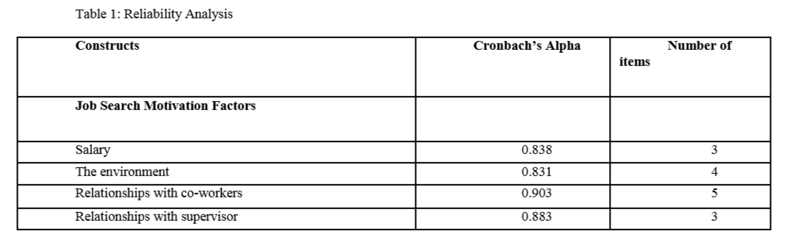
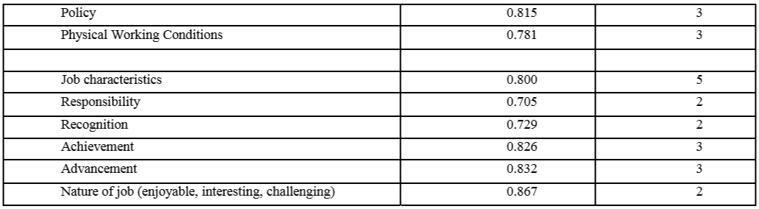

5.2 Content Validity for job search motivation factors
Content validity was emphasised during the development phase of the questionnaire. In this study, content validity of the measurement instrument was assessed by seeking expert opinions from two experienced members of the Human Resources staff at Tenaga Nasional Berhad. Face validity was also examined.
5.3 Job Search Motivation Factors
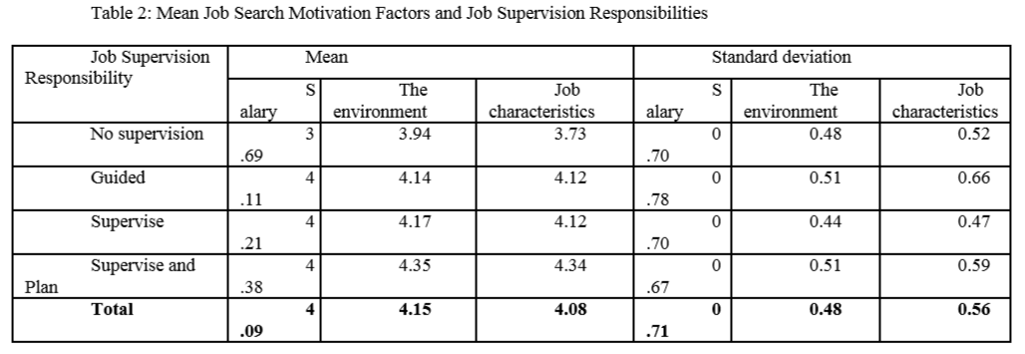
Table 2 illustrates the mean job search motivation factors when compared within each of the four supervision responsibility levels.

Table 2 shows that the environments play a role in influencing employees to search for alternative employment, and indicates that it is important for employees to have comfortable working conditions, a good relationship with supervisors and peers, and company policies for security for the employees.
5.4 Examination of Backgrounds of Employees with Respect to Job Supervision Responsibility Levels in order to Identify Relationships with Job Search Motivation Factors
In this section, three hypotheses (H1, H2, H3), the backgrounds of employees with respect to the levels of job supervision responsibility were compared in order to determine the relationships with job search motivation factors . Different levels of supervision responsibility had different impacts on job search motivation factors. The results are shown in Table 4 (see table below).
H1: The higher the level of responsibility of the job seeker in his current position, the stronger salary is as a motivator for seeking a new job.
H2: The lower the level of responsibility of the job seeker in his current position, the stronger the environment is as a motivator for seeking a new job.
H3: The higher the level of responsibility of the job seeker in his current position, the greater the job characteristic is as a motivator for seeking a new job .
5.5 Summary of Research Objective
Hypotheses 1, 2 and 3 were developed to answer current research objective. The objective was to examine the backgrounds of employees with respect to the levels of job supervision responsibility and to identify the relationships with job search motivation factors. The research around Hypotheses 1, 2 and 3, shows that when searching for a new job, a high job supervision responsibility level is influenced by salary, the environment and jobcharacteristics. This research believes there is a difference between levels of job supervision responsibility, towards job search motivation factors, when the search is on for a new employment opportunity. Table 5 illustrates the answer around the present research objective.
- The implications of the Assessment of Job Search Motivation
The theoretical contribution of the current project is in adding a new construct for measuring the potentially influential search motivator. The new variable of job supervision responsibility has been added for a reason. In terms of theory, the construct "level of job supervision responsibility" does not necessarily represent the level of job or job category. Manove (1997) noted that job supervision responsibility can be known only after employees start their job.
The consequence of this however is that the organisation either retains or loses quality employees. Firstly, when the manager is able to understand employees’ motivation, this results in him being able to prepare the ideal job design that will encompass the right job characteristics. Secondly, the manager being able to understanding the role of extrinsic and intrinsic motivation is very important.
- Conclusion and Directions for Future Study
This study found that different background employees have different job search motivation, then led to different types of job information sought. However, the current research focuses only within job supervision responsibility context. It would be recommended to expand the focus context, so that can explore the complexity of relationship between job title and category, and organisational level and job supervision responsibility. The outcome of current research is to improve employees’ satisfaction. At workplace consideration, job satisfaction is an important dimension of employee well-being (Grant et al, 2007). The satisfaction is achieved when the employees have happiness and excitement in performing the task (Russell & Carroll,1999). Future research could explore information on the employees’ wellbeing, as it would be interesting to examine whether the usage conditions would also work well with current research framework.

